CLASS: B.VOC. FASHION TECHNOLOGY SEM. V
SESSION:2021-2022
INTERNSHIP DETAILS
TOTAL NO. OF STUDENTS:13
S. NO | ROLL NO | NAME OF THE STUDENT | NAME OF THE INDUSTRY | PROOF ATTACHED
1 | 51401 | SONALI | PARMESHWARI SILK MILLS, LUDHIANA | 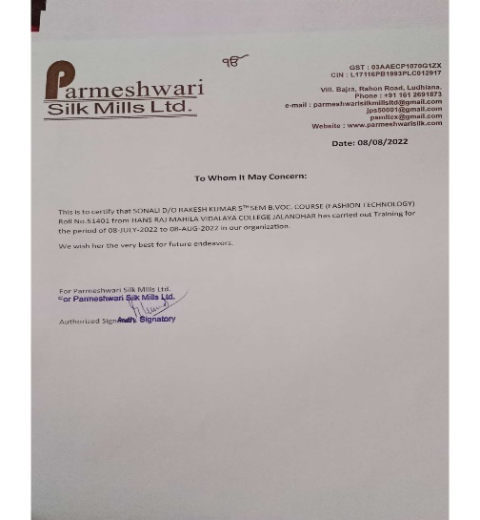
2 | 51402 | SUJATA MALIK | NG APPARELS, LUDHIANA | 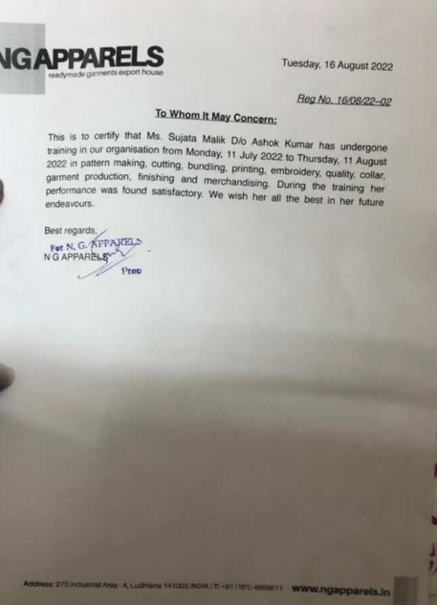
3 | 51403 | NISHA | RK APPARELS, JALANDHAR | 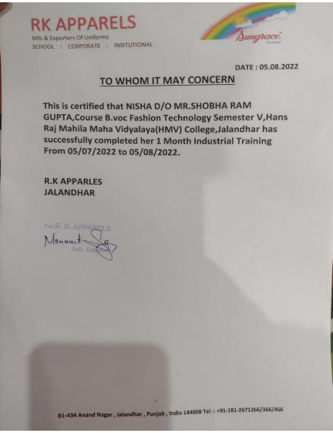
4 | 51404 | PRABHLEEN | NG APPARELS, LUDHIANA | 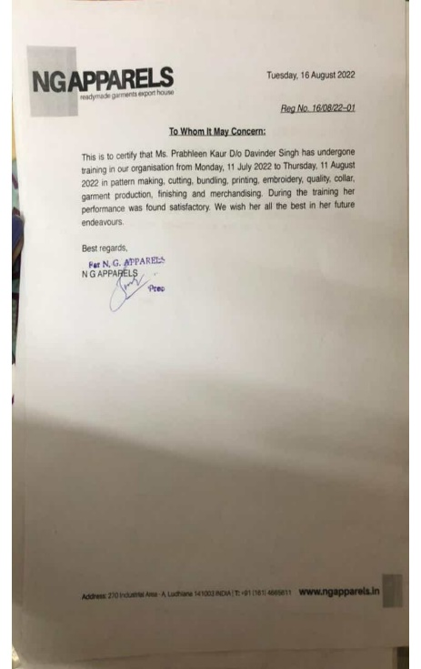
5 | 51408 | SUMANDEEP KAUR | PARMESHWARI SILK MILLS, LUDHIANA | 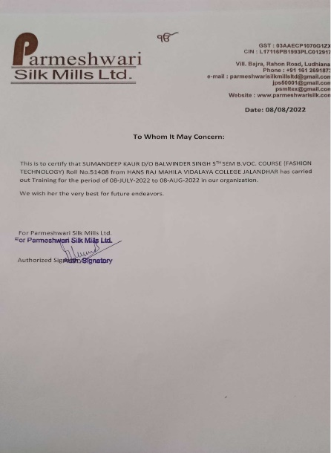
6 | 51410 | SUMIT KAUR | PARMESHWARI SILK MILLS, LUDHIANA | 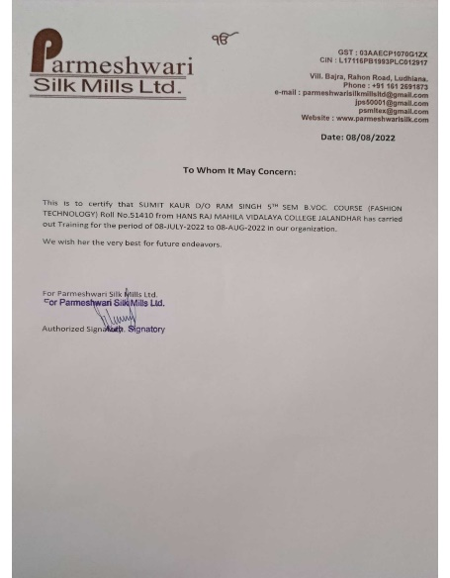
7 | 51413 | JASMEEN | NG APPARELS, LUDHIANA | 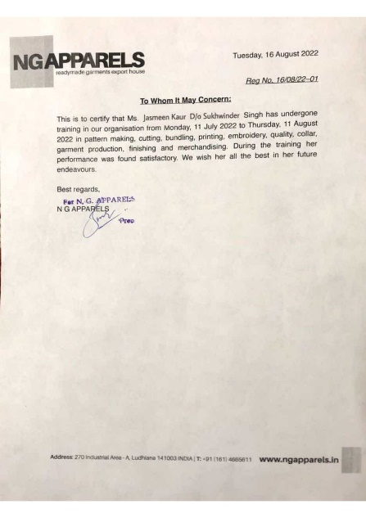
8 | 51414 | JASPREET KAUR | PARMESHWARI SILK MILLS, LUDHIANA | 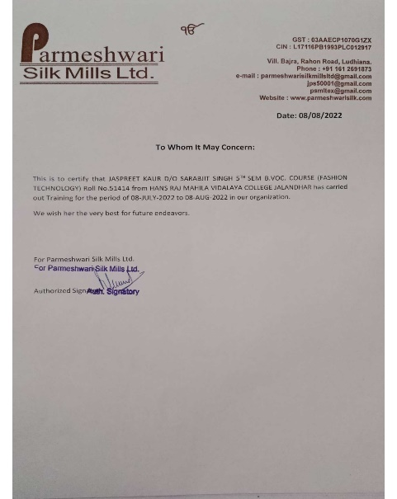
9 | 51415 | SOMIYA | RK APPARELS, JALANDHAR | 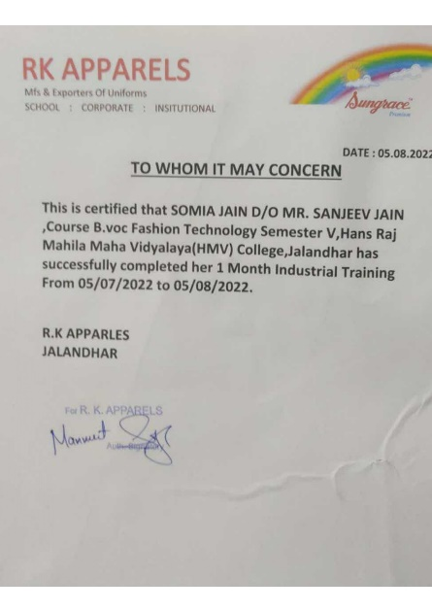
10 | 51417 | JASMINE | NG APPARELS, LUDHIANA | 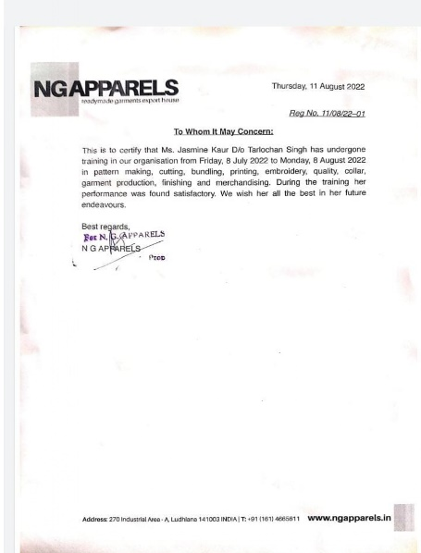
11 | 51418 | JASLEEN | NG APPARELS, LUDHIANA | 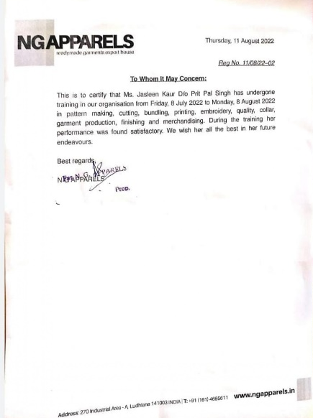
12 | 51419 | GEETA | RK APPARELS, JALANDHAR | 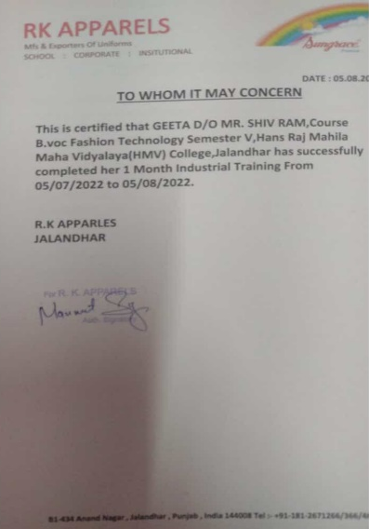
13 | 51420 | AMANDEEP KAUR | NG APPARELS, LUDHIANA | 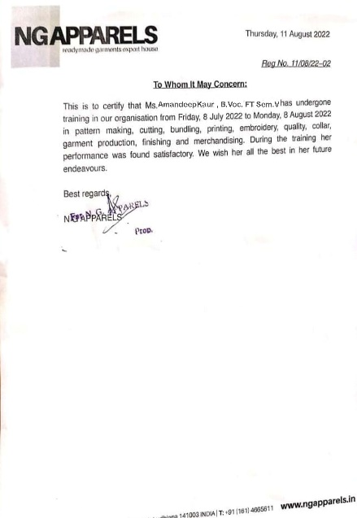
CLASS: M.SC. FASHION DESIGNING & MERCHANDISING SEM. III
TOTAL NO OF STUDENTS:14
S. NO | ROLL NO | NAME OF THE STUDENT | NAME OF THE INDUSTRY | PROOF ATTACHED
1 | 55251 | RITU | UMANG INTERNATIONAL, BASTI BAWA KHEL, JALANDHAR | 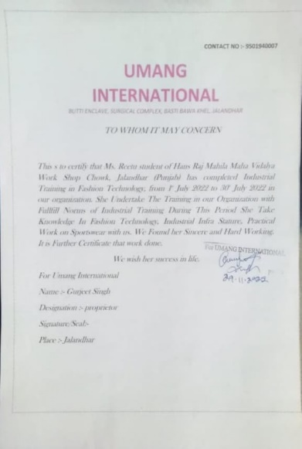
2 | 55252 | SIMRANJEET KAUR | NEVA GARMENT LTD, LUDHIANA | 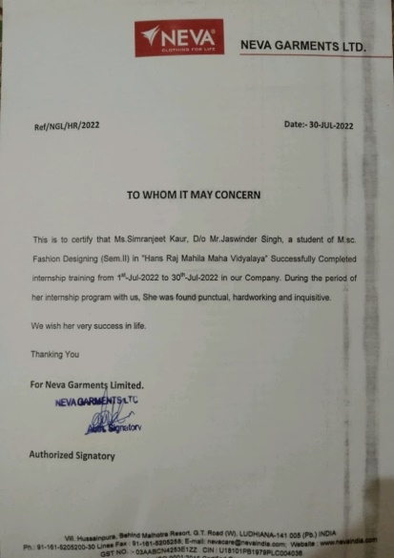
3 | 55253 | PRINCY | MAHIR CLOTHING, 93-B, INDUSTRIAL ESTATE, LUDHIANA | 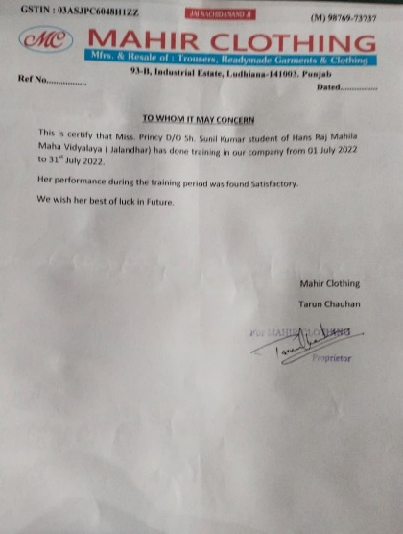
4 | 55254 | MANSI | GARG ACRYLICS LIMITED, LUDHIANA | 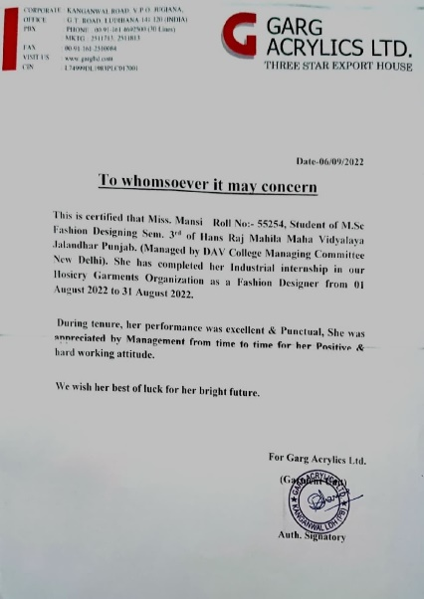
5 | 55255 | ANUPAMA | GARG ACRYLICS LIMITED, LUDHIANA | 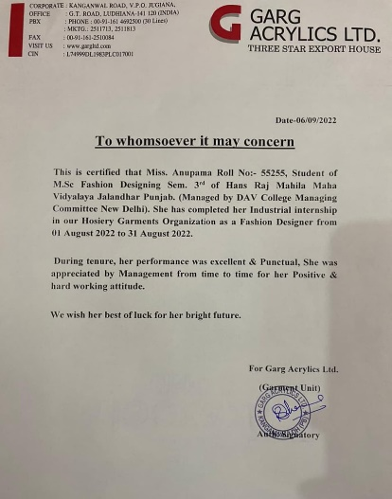
6 | 55256 | GURPREET KAUR | GARG ACRYLICS LIMITED, LUDHIANA | 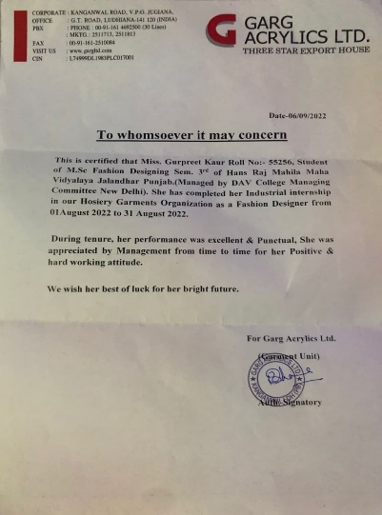
7 | 55257 | HARPREET KAUR | JAWANDSONS PRIVATE LIMITED, LUDHIANA | 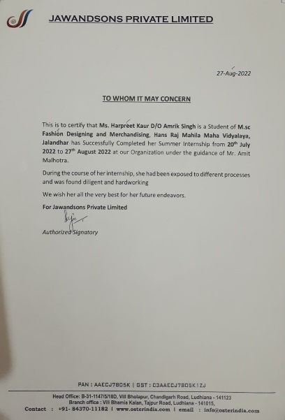
8 | 55258 | SMILY | NEVA GARMENT LTD, LUDHIANA | 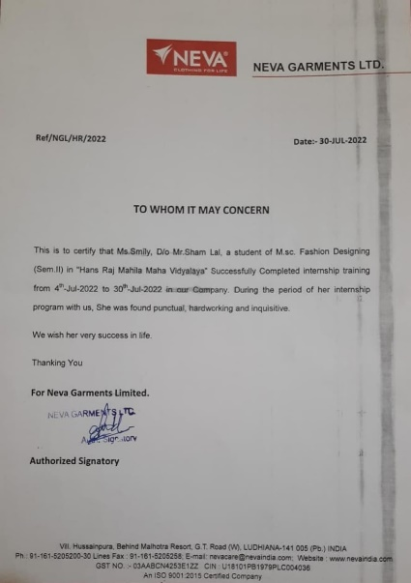
9 | 55260 | JASLEEN KAUR | NEVA GARMENT LTD, LUDHIANA | 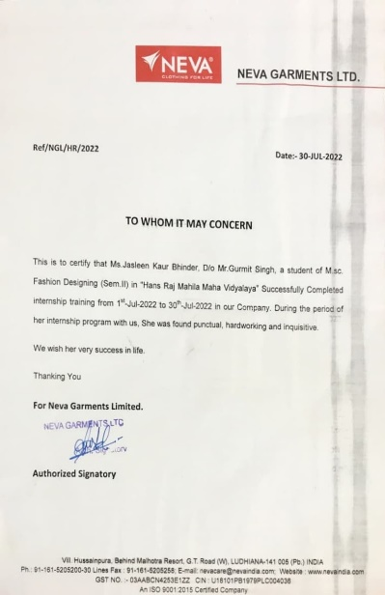
10 | 55261 | DIKSHA GUPTA | KUNDRA TEXTILE MILLS, JALANDHAR | 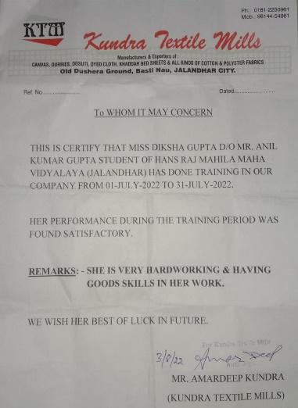
11 | 55262 | ASHIMA | MK HOSIERY, LUDHIANA | 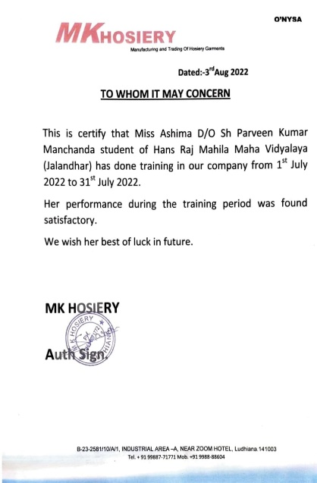
12 | 55263 | NAVDEEP | MERRY FASHION BOUTIQUE, SHAHKOT JALANDHAR | 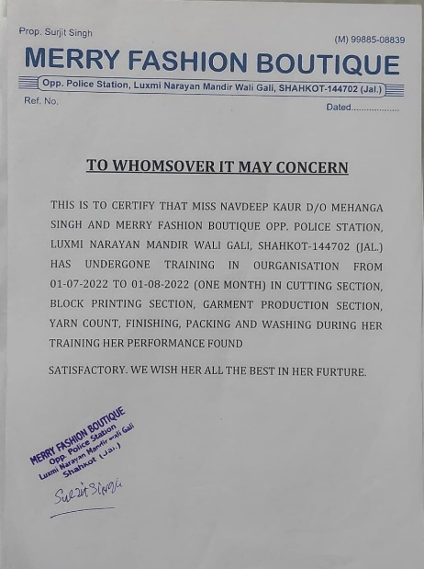
13 | 55266 | GURPREET KAUR | NEVA GARMENT LTD, LUDHIANA | 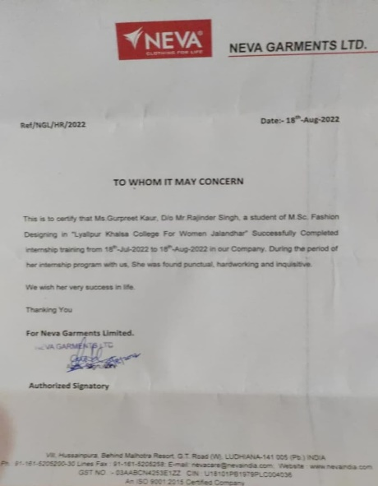
14 | 55267 | SATWINDER | NEVA GARMENT LTD, LUDHIANA | 